**E-RESTAURANT APPLICATION**

**A PROJECT REPORT**

## Submitted by

**AYUSH DWIVEDI (2200290140045)**

**AYUSH NARAYAN MAURYA (2200290140046)**

**AYUSHI SINGH (2200290140047)**

**Submitted in partial fulfilment of the**

**Requirements for the Degree of**

MASTER OF COMPUTER APPLICATION

**Under the Supervision of**

**Dr. Vipin Kumar**

**(Associate Professor)**



**Submitted to**

**Department Of Computer Applications**

**KIET Group of Institutions, Ghaziabad Uttar Pradesh-201206**

**(June-2024)**

**DECLARATION**

I hereby declare that the work presented in this report entitled “E-Restaurant application ”, was carried out by me. I have not submitted the matter embodied in this report for the award of any other degree or diploma of any other University or Institute. I have given due credit to the original authors/sources for all the words, ideas, diagrams, graphics, computer programs, experiments, results, that are not my original contribution. I have used quotation marks to identify verbatim sentences and given credit to the original authors/sources. I affirm that no portion of my work is plagiarized, and the experiments and results reported in the report are not manipulated. In the event of a complaint of plagiarism and the manipulation of the experiments and results, I shall be fully responsible and answerable.

**Name:** Ayush Dwivedi (2200290140045)

Ayush Narayan Maurya (2200290140046)

Ayushi Singh (2200290140047)

**(Candidate Signature)**

# **CERTIFICATE**

Certified that **Ayush Dwivedi (2200290140045), Ayush Narayan Maurya (2200290140046), Ayushi Singh (2200290140047)** have carried out the project work having “E-Restaurant application" for Master of Computer Applications from Dr. A.P.J. Abdul Kalam Technical University (AKTU**)**, Lucknow under my supervision. The project report embodies original work, and studies are carried out by the student himself / herself and the contents of the project report do not form the basis for the award of any other degree to the candidate or to anybody else from this or any other University/Institution.

**Date:**

**Ayush Dwivedi (2200290140045)**

**Ayush Narayan Maurya (2200290140046)**

**Ayushi Singh (2200290140047)**

This is to certify that the above statement made by the candidate is correct to the best of my knowledge.

**Date:**

**Dr. Vipin Kumar Dr. Arun Tripathi**

**Associate Professor Head**

**Department of Computer Applications Department of Computer Applications**

**KIET Group of Institutions, Ghaziabad KIET Group of Institutions, Ghaziabad**

# **ABSTRACT**

This project presents an E-Restaurant application developed using Python, designed to streamline the dining experience by integrating digital ordering, payment, and management systems. The application caters to both customers and restaurant staff, offering a user-friendly interface for browsing menus, placing orders, and making payments. For customers, the app provides real-time menu updates, customization options, and order tracking. For restaurant staff, it features tools for managing orders, inventory, and reservations.

The application leverages Flask for the web framework, SQLite for the database, and RESTful APIs for seamless communication between the front-end and back-end. It incorporates essential features such as user authentication, secure payment processing, and data encryption to ensure privacy and security. Additionally, the app employs machine learning algorithms to analyze customer preferences and recommend dishes, enhancing the overall dining experience.

This E-Restaurant application aims to increase operational efficiency, reduce wait times, and improve customer satisfaction by providing a comprehensive digital solution for modern restaurants. The use of Python ensures flexibility, scalability, and ease of maintenance, making it a robust platform for the evolving needs of the restaurant industry.

# **ACKNOWLEDGEMENTS**

Success in life is never attained single-handedly. My deepest gratitude goes to my thesis supervisor, **Dr. Vipin Kumar** for his guidance, help and encouragement throughout my research work. Their enlightening ideas, comments, and suggestions.

Words are not enough to express my gratitude to **Dr. Arun Kumar Tripathi**, Professor and Head, Department of Computer Applications, for his insightful comments and administrative help at various occasions.

Fortunately, I have many understanding friends, who have helped me a lot on many critical conditions.

Finally, my sincere thanks go to my family members and all those who have directly and indirectly provided me with moral support and other kind of help. Without their support, completion of this work would not have been possible in time. They keep my life filled with enjoyment and happiness.

**Ayush Dwivedi**

**Ayush Narayan Maurya**

**Ayushi Singh**

**TABLE OF CONTENTS**

|  |  |  |  |
| --- | --- | --- | --- |
|  | Declaration |  | ii |
|  | Certificate |  | iii |
|  | Abstract |  | iv |
|  | Acknowledgement |  | v |
|  | Table of Contents |  | vi-vii |
|  | List of Figures |  | viii |
|  | List of Tables |  | ix |
| 1 | Introduction |  | 1-3 |
|  | 1.1 | Overview | 1 |
|  | 1.2 | Objective | 2 |
|  | 1.3 | Project Features | 2-3 |
| 2 | Literature Review |  | 4-5 |
| 3 | Feasibility Study |  | 6-7 |
|  | 3.1 | Technical Feasibility | 6 |
|  | 3.2 | Economical Feasibility | 6 |
|  | 3.3 | Operational Feasibility | 7 |
|  | 3.4 | Scheduling Feasibility | 7 |
|  | 3.5 | Security and Privacy Feasibility | 7 |
|  | 3.6 | User Engagement and Feedback | 7 |
| 4 | Requirement Analysis |  | 8-10 |
|  | 4.1 | Functional Requirement | 8-9 |
|  |  |  |  |

|  |  |  |  |
| --- | --- | --- | --- |
|  | 4.2 | Non-Functional Requirement | 9-10 |
|  | 4.3 | Software Requirement | 10 |
|  | 4.4 | Hardware Requirement | 10 |

|  |  |  |  |
| --- | --- | --- | --- |
| 5 | System Architecture and Design |  | 11-14 |
|  | 5.1 | ER-Diagram | 11 |
|  | 5.2 | Case Study Diagram | 12 |
|  | 5.3.1 | Data Flow Diagram 0-level | 13 |
|  | 5.3.2 | Data Flow Diagram 1-level | 14 |

|  |  |  |  |
| --- | --- | --- | --- |
| 6 | Database Design |  | 15-14 |
|  | 6.1 | Introduction | 15 |
|  | 6.2 | Data Modeling | 15 |
|  | 6.3 | Use Cases | 16 |
|  | 6.4 | Schema Design | 16 |
|  | 6.5 | Link Related Data | 17-18 |
|  | 6.6 | Data Storage and Retrieval | 18 |
| 7 | Form Design |  | 19-24 |
|  | 7.1 | Landing Page | 19 |
|  | 7.2 | List Of Recipes | 20 |
|  | 7.3 | Login Page | 21 |
|  | 7.4 | Register Page | 22 |
|  | 7.5 | Adding Recipe Page | 23 |
|  | 7.6 | Search Recipe Page | 24 |
| 8 | Testing |  | 25-26 |
|  | 8.1 | Testing Case 1 (Login) | 25 |
|  | 8.2 | Testing Case 2 (Adding Recipes) | 25-26 |
|  | 8.3 | Testing Case 3 (Logout) | 26 |
| 9 | Bibliography |  | 27 |

**LIST OF FIGURES**

|  |  |  |  |
| --- | --- | --- | --- |
| **Figure No.** | **Name of Figure** | **Page No.** | |
| 5.1 | ER Diagram |  | 11 |
| 5.2 | Case Study Diagram |  | 12 |
| 5.3.1 | Data Flow Diagram 0-level |  | 13 |
| 5.3.2 | Data Flow Diagram 1-level |  | 14 |
| 6.5.1 | Embedded Data |  | 17 |
| 6.5.2 | References |  | 18 |
| 7.1 | Landing Page |  | 19 |
| 7.2 | List Of Recipes |  | 20 |
| 7.3 | Login Page |  | 21 |
| 7.4 | Register Page |  | 22 |
| 7.5 | Adding Recipe Page |  | 23 |
| 7.6 | Search Recipe Page | | 24 |

**LIST OF TABLES**

|  |  |  |
| --- | --- | --- |
| **Figure No.** | **Name of Figure** | **Page No.** |
| 4.3 | Software Requirement for Pantry2Plate | 10 |
| 4.4 | Hardware Requirement for Pantry2Plate | 10 |

**CHAPTER 1**

**INTRODUCTION**

**1.1 OVERVIEW**

Our The e-Restaurant application is a cutting-edge digital platform designed to enhance restaurant operations and customer experiences through advanced technology. Developed using Python, this application integrates key features to streamline processes and improve service quality.

The online reservation system allows customers to book tables effortlessly, with real-time updates to prevent overbooking. Automated reminders via email and SMS reduce no-shows, ensuring efficient table management.

A dynamic digital menu enables restaurant managers to update items, prices, and descriptions in real-time, supporting rich media like images and videos to showcase dishes attractively. Special offers and promotions can be highlighted to encourage upselling and enhance customer engagement.

Order management is optimized through digital ordering, where waitstaff use tablets or smartphones to take orders that are instantly transmitted to the kitchen, minimizing errors and delays. Customers can track their order status in real-time, enhancing transparency and reducing wait times. The application also allows for order customization, meeting customers' dietary preferences.

The customer feedback system is integral for continuous improvement, allowing patrons to rate their dining experience and leave reviews within the application. Detailed analytics on feedback help identify trends and areas for enhancement, ensuring high customer satisfaction. Management can respond to feedback, demonstrating value for customer opinions and fostering loyalty.

Inventory management is made efficient with real-time stock level tracking and automated alerts for low inventory, ensuring timely reordering and preventing service disruptions. Comprehensive inventory reports assist in optimizing stock management and reducing waste.

Secure billing and payment processing are integrated, supporting various payment gateways and methods, including credit/debit cards and digital wallets. The application also handles split bills seamlessly, catering to groups.

Overall, the e-Restaurant application offers a robust, user-friendly, and scalable solution that leverages technology to meet the evolving needs of modern restaurants, enhancing operational efficiency and delivering exceptional customer experiences.

**1.2 OBJECTIVE**

The primary objective of the e-Restaurant application is to revolutionize the restaurant industry by creating a seamless, efficient, and customer-centric digital platform utilizing Python-based technology. This application aims to transform various aspects of restaurant operations to enhance both the customer experience and overall operational efficiency.

A key goal is to enhance the customer experience by providing an intuitive interface for online reservations, real-time menu updates, and digital ordering. This ensures a convenient and enjoyable dining experience where customers can easily book tables, customize their orders, and track the status of their meals, leading to higher satisfaction and increased repeat business.

Optimizing restaurant operations is another crucial objective. By automating tasks such as reservations, order management, and inventory tracking, the application reduces manual work and errors, leading to increased productivity and smoother workflows. Real-time updates and notifications help manage inventory efficiently, preventing both shortages and overstocking, which in turn minimizes waste and ensures a consistent supply of ingredients.

The application also facilitates data-driven decision-making by collecting and analyzing customer feedback, sales data, and inventory usage. These insights provide valuable information for restaurant managers, enabling them to make informed decisions that improve service quality, refine menu offerings, and optimize overall operations.

Ensuring security and reliability is paramount. The application integrates secure payment gateways and maintains the confidentiality of customer data, ensuring safe and reliable transaction processing. By prioritizing data protection, the application builds trust with users and ensures a safe dining experience.

Lastly, the e-Restaurant application is designed to support scalability and flexibility. It can adapt to the growing needs of restaurants, allowing for easy integration of new features and third-party services. This flexibility ensures the application remains viable and relevant in a competitive market, supporting sustainable growth and long-term success for restaurants.

**1.3 PROJECT FEATURE**

The e-Restaurant application boasts a range of features designed to streamline restaurant operations and enhance the dining experience. Central to its functionality is an intuitive online reservation system that allows customers to book tables effortlessly, with real-time updates ensuring optimal table management. The dynamic digital menu is another standout feature, enabling restaurant managers to make real-time updates to items, prices, and descriptions, and supporting rich media like images and videos to attractively showcase dishes.

Order management is greatly simplified with digital ordering, where waitstaff can use tablets or smartphones to transmit orders directly to the kitchen, minimizing errors and improving service speed. Customers can also track their orders in real-time and customize them to meet their preferences. The application includes a robust customer feedback system, allowing patrons to rate their experience and leave reviews, which are analyzed to provide valuable insights for improvement.

Inventory management is enhanced with real-time tracking of stock levels and automated alerts for low inventory, ensuring timely restocking and reducing waste. Secure billing and payment processing are integrated into the system, supporting multiple payment methods and ensuring safe transactions. Additionally, the application’s design supports scalability and flexibility, allowing it to grow and adapt with the restaurant’s needs.

**CHAPTER 2**

**LITERATURE REVIEW**

The e-Restaurant application builds on a substantial body of literature exploring the impact of digital technologies on the restaurant industry. Research indicates that online reservation systems significantly improve table management and customer satisfaction by reducing waiting times and ensuring efficient seating arrangements. Studies on digital menus reveal that they enhance the dining experience by providing interactive and visually appealing displays of menu items, which can include detailed descriptions, images, and videos, thereby aiding customers in making informed choices.

Order management systems have been extensively studied for their role in minimizing human error and expediting service. Digital ordering devices, such as tablets and smartphones, streamline the communication between waitstaff and kitchen staff, leading to faster and more accurate order fulfillment. Customer feedback systems are also crucial, as they provide valuable data that helps restaurants continuously improve their services. Research shows that analyzing customer feedback can lead to significant enhancements in service quality and customer satisfaction.

Inventory management is another critical area where technology has proven beneficial. Real-time inventory tracking and automated alert systems help restaurants maintain optimal stock levels, reducing waste and ensuring the availability of ingredients. Secure billing and payment processing technologies are vital for protecting customer data and facilitating smooth transactions, which are essential for building trust and loyalty.

Overall, the literature underscores the importance of integrating these technological solutions into restaurant operations to improve efficiency, enhance the customer experience, and provide actionable insights for business improvement. The e-Restaurant application leverages these findings to offer a comprehensive and innovative solution tailored to the modern restaurant industry.

**CHEPTER 3**

**SYSTEM ANALYSYS**

1. **INTRODUCTION**

System analysis for the e-Restaurant application involves a thorough examination of existing restaurant operations to identify opportunities for enhancement. Through interviews, surveys, and observations, analysts gather requirements from stakeholders to understand their needs and challenges. Models and prototypes are then developed to visualize the proposed system's structure and functionality, ensuring alignment with stakeholder goals. By systematically analyzing workflows and identifying areas for improvement, system analysis sets the stage for the successful development and implementation of the e-Restaurant application, aiming to optimize efficiency and enhance the dining experience for both customers and staff..

1. **EXISTING SYSTEM**

The existing system comprises manual processes for reservations, order management, and inventory tracking in restaurants. It lacks digital solutions, leading to inefficiencies, longer wait times, and increased potential for errors. This system impedes operational agility and may result in suboptimal customer experiences.

**3.1 LIMITATION OF EXISTING SYSTEM**

The limitations of the existing system include manual processes for reservations and order management, leading to inefficiencies and longer wait times for customers. Lack of real-time inventory tracking results in potential stock shortages and overstocking, leading to wastage. Moreover, manual processes increase the likelihood of errors and inconsistencies in service. Overall, the existing system hampers operational agility and does not fully meet the demands of modern customers for efficient and seamless dining experiences.

1. **FEASIBILITY STUDY**

The feasibility study for the e-Restaurant application assesses its technical, economic, and operational viability. It evaluates factors such as available technology, development costs, market demand, and potential return on investment. By analyzing these factors, stakeholders can determine whether the project is feasible and worth pursuing. The study also helps identify potential risks and challenges that may impact the project's success, allowing for informed decision-making and strategic planning.

There are six parts in feasibility study

1. Technical Feasibility
2. Economic Feasibility
3. Operational Feasibility
4. Scheduling Feasibility
5. Security and Privacy Feasibility
6. User Engagement and Feedback

**3.1 TECHNICAL FEASIBILITY**

The e-Restaurant application's technical feasibility using Python, Django, HTML, CSS, and Bootstrap is promising. Python's versatility and robustness make it suitable for backend development, while Django provides a framework for rapid development and scalability. HTML and CSS are used for frontend design, ensuring a visually appealing and user-friendly interface. Bootstrap enhances responsiveness and facilitates cross-platform compatibility. Integrating these technologies offers a solid foundation for developing a dynamic and efficient e-Restaurant application, aligning with modern web development standards and enabling seamless integration with existing technology infrastructure.

**3.2 ECONOMIC FEASIBILITY**

The economic feasibility of the e-Restaurant application involves evaluating its cost-effectiveness and potential return on investment. This includes assessing development costs, operational expenses, and revenue projections. By comparing the expected benefits against the project's expenses, stakeholders can determine whether the investment is financially viable. Factors such as market demand, competitive landscape, and long-term sustainability are also considered. Ultimately, a positive economic feasibility analysis indicates that the e-Restaurant application is likely to deliver value and generate profit over time.

**3.3 OPERATIONAL FEASIBILITY**

Operational feasibility evaluates the practicality and effectiveness of implementing the e-Restaurant application within the organization's operations. This involves assessing how well the application aligns with existing processes, user workflows, and organizational culture. Factors such as user acceptance, training needs, and potential disruptions to daily operations are considered. By understanding these aspects, stakeholders can identify potential challenges and develop strategies to mitigate risks. Operational feasibility ensures that the e-Restaurant application can be successfully integrated into the organization's operations, delivering tangible benefits while minimizing disruption and maximizing user adoption..

**3.4 SCHEDULING FEASIBILITY**

Scheduling feasibility assesses the e-Restaurant application's ability to meet project deadlines and milestones within the allocated timeframe. This involves evaluating the availability of resources, including personnel, technology, and budget, necessary to complete the project on schedule. Factors such as development complexity, dependencies, and potential risks are considered when creating a realistic project schedule. By ensuring that the project timeline aligns with organizational goals and constraints, stakeholders can effectively manage project timelines, allocate resources efficiently, and mitigate scheduling conflicts to ensure timely delivery of the e-Restaurant application.

**3.5 SECURITY AND PRIVACY FEASIBILITY**

Security and privacy feasibility assesses the e-Restaurant application's ability to safeguard sensitive data and protect user privacy. This involves implementing robust security measures, such as encryption protocols, authentication mechanisms, and access controls, to prevent unauthorized access and data breaches. Additionally, compliance with data protection regulations, such as GDPR or CCPA, is essential to ensure legal and ethical handling of user information. By prioritizing security and privacy measures, stakeholders can instill trust in users and mitigate the risks associated with cyber threats, thereby enhancing the feasibility and reliability of the e-Restaurant application..

**3.6 USER ENGAGEMENT AND FEEDBACK**

User engagement and feedback feasibility evaluate the e-Restaurant application's potential to foster meaningful interactions with users and collect valuable feedback. This involves implementing features such as interactive menus, personalized recommendations, and seamless ordering processes to enhance user engagement. Additionally, incorporating feedback mechanisms, such as rating systems and comment sections, enables users to provide valuable insights for continuous improvement. By prioritizing user engagement and feedback, stakeholders can cultivate a positive user experience, foster customer loyalty, and drive iterative enhancements to the e-Restaurant application, ensuring its long-term success and viability.

1. **PROPOSED SYSTEM**

The proposed system, the e-Restaurant application, aims to revolutionize restaurant operations by leveraging digital technology to enhance efficiency, improve customer experiences, and drive business growth. Built on a robust tech stack comprising Python, Django, HTML, CSS, and Bootstrap, the application offers a comprehensive suite of features designed to streamline various aspects of restaurant management.

Key features of the proposed system include an intuitive online reservation system, dynamic digital menu management, efficient order processing, inventory management, secure billing and payment processing, and robust customer feedback mechanisms. These features are tailored to meet the specific needs of modern restaurants and deliver seamless experiences for both customers and staff.

The proposed system's architecture enables scalability, flexibility, and compatibility with existing technology infrastructure, ensuring smooth integration and long-term viability. By addressing the limitations of manual processes and embracing digital solutions, the e-Restaurant application offers a cost-effective and sustainable solution for restaurants to thrive in today's competitive market landscape. Overall, the proposed system aims to optimize operational workflows, enhance customer satisfaction, and drive profitability for restaurant businesses.

**4.1 ADVANTAGE OF PROPOSED SYSTEM**

The proposed e-Restaurant application offers advantages such as streamlined operations, improved efficiency, enhanced customer experiences, and increased profitability. By leveraging digital technology and automation, it enables restaurants to optimize workflows, reduce errors, and better cater to the evolving needs of modern customers, ensuring long-term success.

**CHEPTER 4**

**REQUIREMENT ANALYSIS**

**4.1 FUNCTIONAL REQUIREMENTS**

Functional requirements specify what the system or software should do or the actions it should perform. They describe the intended functionality, features, and capabilities of the system. These requirements outline the system's behaviour, inputs, outputs, and interactions with users or other systems. Functional requirements are typically specific, measurable, and verifiable. Examples include user authentication, data input validation, report generation, and system integration.

* **User Authentication:** Allow customers, staff, and administrators to securely log in with unique credentials.
* **Online Reservation System:** Enable customers to book tables, specify preferences, and receive confirmation.
* **Digital Menu Management:** Allow administrators to update menu items, descriptions, prices, and images in real-time.
* **Order Management:** Provide staff with a digital interface to take orders, customize them, and transmit them to the kitchen.
* **Inventory Management:** Track inventory levels, generate alerts for low stock, and provide reports on usage and trends.
* **Billing and Payment Processing:** Enable secure transactions, support various payment methods, and handle split bills.
* **Customer Feedback System:** Allow customers to rate their experience, leave comments, and receive responses from management.
* **Notifications:** Send automated reminders for reservations, order updates, and promotional offers via email or SMS.
* **Reporting and Analytics:** Generate reports on reservations, orders, inventory, and customer feedback for analysis.
* **User Roles and Permissions:** Assign different access levels to customers, staff, and administrators to control system functionality.
* **Integration with Third-Party Services:** Integrate with payment gateways, notification services, and other APIs for enhanced functionality.
* **Mobile Compatibility:** Ensure the application is responsive and accessible across various devices for user convenience.

**4.2 NON-FUNCTIONAL REQUIREMENTS**

Non-functional requirements for the e-Restaurant application focus on aspects beyond specific functionalities. These include ensuring optimal performance with fast response times and high availability, implementing robust security measures to protect user data, and designing the system to be scalable to accommodate growth and handle increased user traffic efficiently. These aspects collectively contribute to a reliable, secure, and user-friendly application experience.

* **Portability:** System running on one platform can easily be converted to run on another platform.
* **Reliability:** The ability of the system to behave consistently in a user-acceptable manner when operating within the environment for which the system was intended.
* **Availability:** The system should be available at all times, meaning the user can access it using a web browser, only restricted by the down time of the server on which the system runs.
* **Maintainability:** A commercial database is used for maintaining the database and the application server takes care of the site.
* **Security:** Secure access of confidential data (customer information).
* **User friendly:** System should be easily used by the customer.
* **Performance:** Performance should be fast.
* **Efficient:**System should be efficient that it won’t get hang if heavy traffic of order is placed.
* **Safety:**  Data in the database of system should not loss or damage.

**4.3 SOFTWARE REQUIREMENT**

|  |  |  |
| --- | --- | --- |
| **S. NO.** | **DESCRIPTION** | **TYPE** |
| 1 | Operating System | Windows, MacOS |
| 2 | Language | HTML5, CSS3, ,  Bootstrap, Python, Django |
| 3 | IDE | VS Code |
| 4 | Database | MongoDB |

**Table 4.3 Software Requirement for Pantry2Plate**

**4.4 HARDWARE REQUIREMENTS**

|  |  |  |
| --- | --- | --- |
| **S. NO.** | **DESCRIPTION** | **TYPE** |
| 1 | Hardware | I3 Processor |
| 2 | Clock Speed | 3.0GHz |
| 3 | RAM | 8GB |
| 4 | SSD | 512GB |

**Table 4.4 Hardware Requirement for Pantry2Plate**

**CHEPTER 5**

**SYSTEM ARCHITECTURE AND DESIGN**

1. **INTRODUCTION**

In this project design technique used is top-down, object- oriented dynamic modelling technique. A top-down design approach starts by identifying the major components and iterating until the desired level of details is achieved. In object-oriented design technique, the modules in the design represent data abstraction. A dynamic model aims to specify new the state of various objects changes as events occur.

1. **INPUT DESIGN**

Input design for the e-Restaurant application involves defining how users interact with the system to input data and commands effectively. This includes designing intuitive interfaces for tasks such as making reservations, placing orders, and providing feedback. Considerations include user-friendly layouts, clear instructions, and validation mechanisms to ensure data accuracy. By prioritizing usability and accessibility, input design aims to enhance the user experience, streamline processes, and minimize errors, ultimately contributing to the overall efficiency and effectiveness of the application.

1. **OUTPUT DESIGN**

Output design for the e-Restaurant application focuses on presenting information to users in a clear, organized, and visually appealing manner. This includes designing interfaces to display reservation confirmations, order details, menu items, and feedback responses. Considerations involve formatting data for readability, incorporating relevant visuals such as images or icons, and providing navigation options for easy access to information. By prioritizing clarity and usability, output design aims to enhance user satisfaction, facilitate decision-making, and improve overall user experience within the application.

1. **DATABASE DESIGN**

Database design is the process of producing a detailed data model of database. This data model contains all the needed logical and physical design choices and physical storage The process of doing database design generally consists of a number of steps which will be carried out by the database designer. Usually, the designer must:

1. Determine the data to be stored in the database.
2. Determine the relationships between the different data elements.
3. Superimpose a logical structure upon the data on the basis of these relationships.

In this project database design generally, the data is to be stored in the database whether it can more relation for each module. And it provides the logical relation between them.

1. **ARCHETECTURAL DESIGN**

Architectural design for the e-Restaurant application involves defining the system's structure and components to ensure scalability, flexibility, and maintainability. This includes determining the overall architecture style, such as client-server or microservices, and identifying the key modules and layers. Considerations involve selecting appropriate technologies and frameworks, defining communication protocols, and ensuring separation of concerns. By providing a blueprint for development, architectural design enables efficient implementation, integration, and evolution of the application while addressing both functional and non-functional requirements.

1. **SYSTEM MODULES**
2. **Admin module**

The admin module in the e-Restaurant application empowers administrators to manage system settings, user accounts, menu items, and reservations. It facilitates tasks such as updating menu items, monitoring reservation activity, and generating reports. The admin module ensures efficient oversight and control over various aspects of the restaurant's operations.

1. **User module**

The user module in the e-Restaurant application provides functionality for customers to interact with the system. It allows users to create accounts, make reservations, browse the menu, place orders, provide feedback, and view their order history. The user module enhances the dining experience by offering convenient and personalized services tailored to individual preferences.

1. **Employee module**

The employee module in the e-Restaurant application facilitates staff management and operational tasks. It allows employees to log in, view their schedules, manage orders, update order statuses, and communicate with customers. Additionally, the employee module may include features for training, performance evaluation, and task assignments, streamlining restaurant operations and improving staff productivity.

**7. DESIGN**

**7.1 USE CASE DIAGRAM**

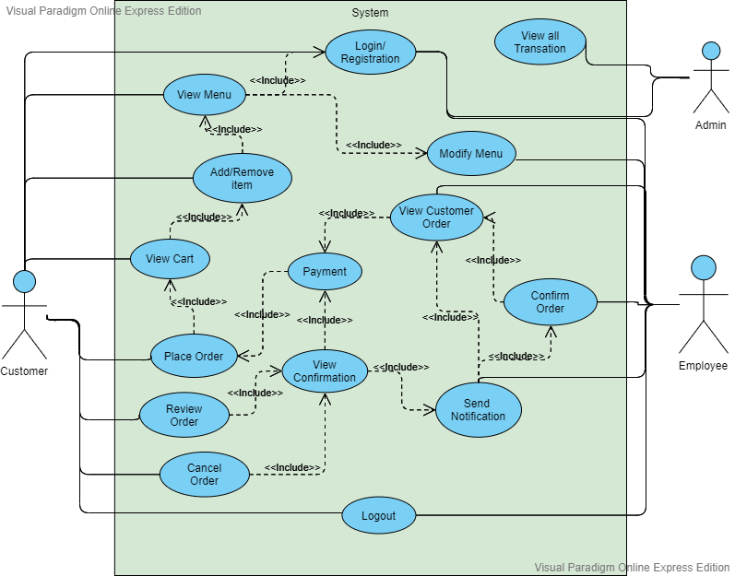

**Fig 5.1 USE CASE DIAGRAM**

A use case diagram for the e-Restaurant application illustrates interactions between users and the system, depicting various actions users can perform and how they relate to system functionalities. It identifies actors, such as customers, employees, and administrators, and showcases their interactions, including making reservations, placing orders, and managing menus, providing a visual representation of system behavior.

In this use case diagram proposed have 3 actors, namely Customer, Employee and Admin.

* Customers can access the website to place orders and payments while Employee and Admin can access the website to receive orders, payments and making order report.
* Use case starts from login into the website with the customer's username and

password, ordering food, making payment. Then Employee makes an order report

based on customer order data.

**7.2 CLASS DIAGRAM:**

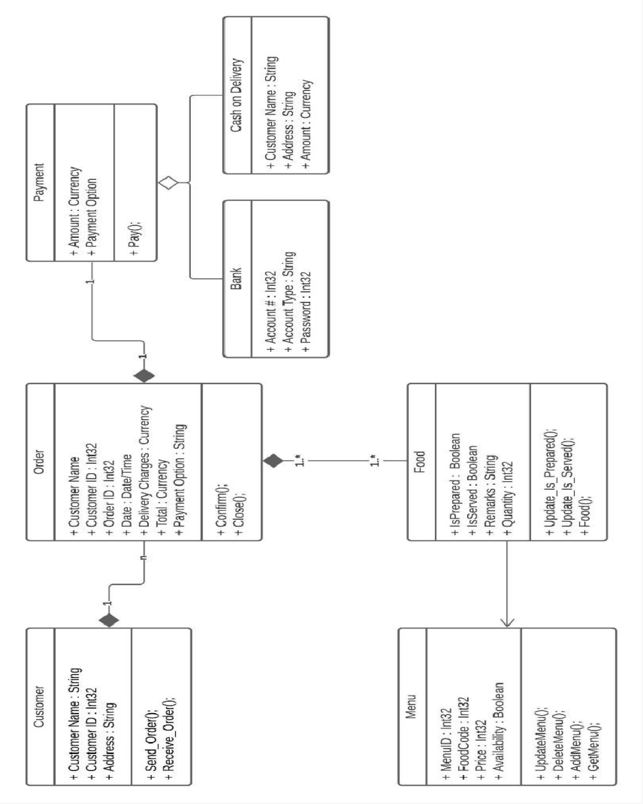The class diagram for the e-Restaurant application illustrates the system's structure by defining classes, their attributes, methods, and relationships. It identifies key classes such as User, Employee, Reservation, Menu Item, and Order, showcasing their properties and interactions. Associations between classes represent relationships, such as "User makes Reservation" or "Employee manages Order." Additionally, inheritance and aggregation relationships may be depicted to show hierarchical and compositional associations. The class diagram provides a blueprint for system implementation, aiding in the organization, design, and understanding of the application's components and functionalities.

**Fig 5.2 USE CASE DIAGRAM**

**7.3 DATA FLOW DIAGRAM**

The data flow diagram shows the flow of data within any system. It is an important tool for designing phase of software engineering. Larry Constantine first developed it. It represents graphical view of flow of data. It’s also known as BUBBLE CHART. The purpose of DFD is major transformation that will become in system design symbols used in DFD: -

In the DFD, four symbols are used and they are as follows.

* + 1. A square defines a source (originator) or destination of system data.
    2. An arrow identifies data flow-data in motion. It is 2a pipeline through which information flows.
    3. A circle or a “bubble “(Some people use an oval bubble) represents a process that transfers informing data flows into outgoing data flows.
    4. An open rectangle is a data store-data at rest, or a temporary repository of data.

**7.3..1 CONTEXT LEVEL DIAGRAM**

The context level diagram for the e-Restaurant application provides an overview of system interactions with external entities. It depicts the system as a single entity interacting with actors such as customers, employees, and administrators. This high-level view illustrates the system's boundaries and major external interfaces, offering a simplified representation of its functionality and interactions with the surrounding environment.

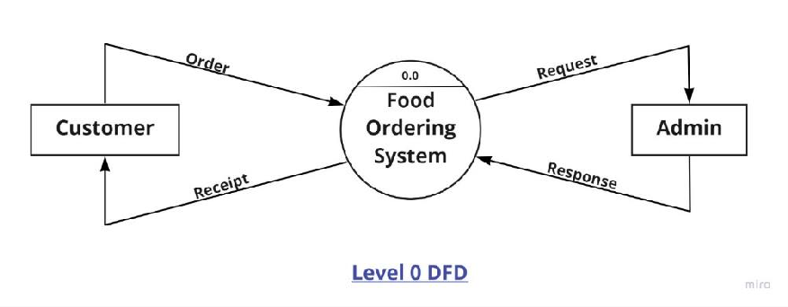

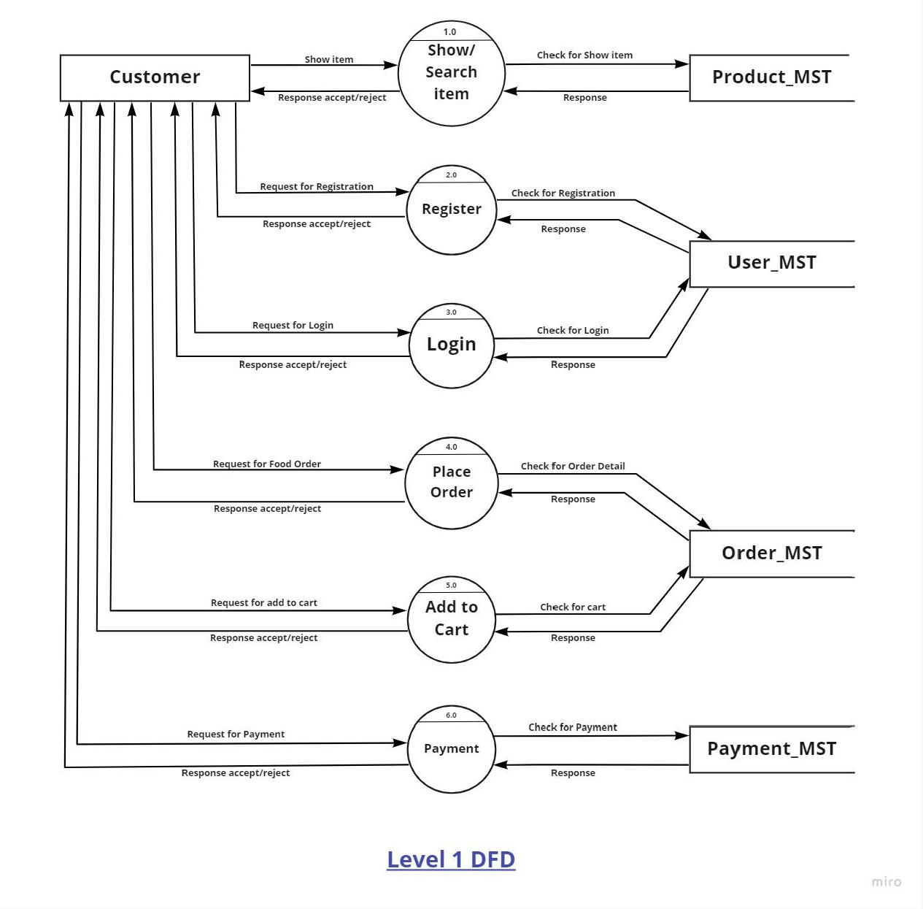

**Fig5.3: First Level DFD**

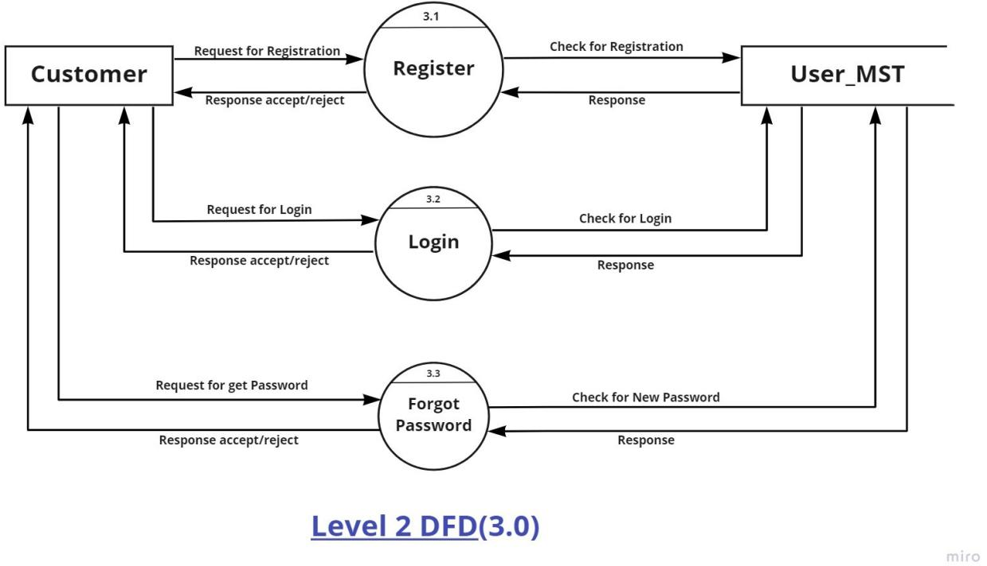­­­

**Fig: Second Level DFD**

**Fig: Admin Level DFD**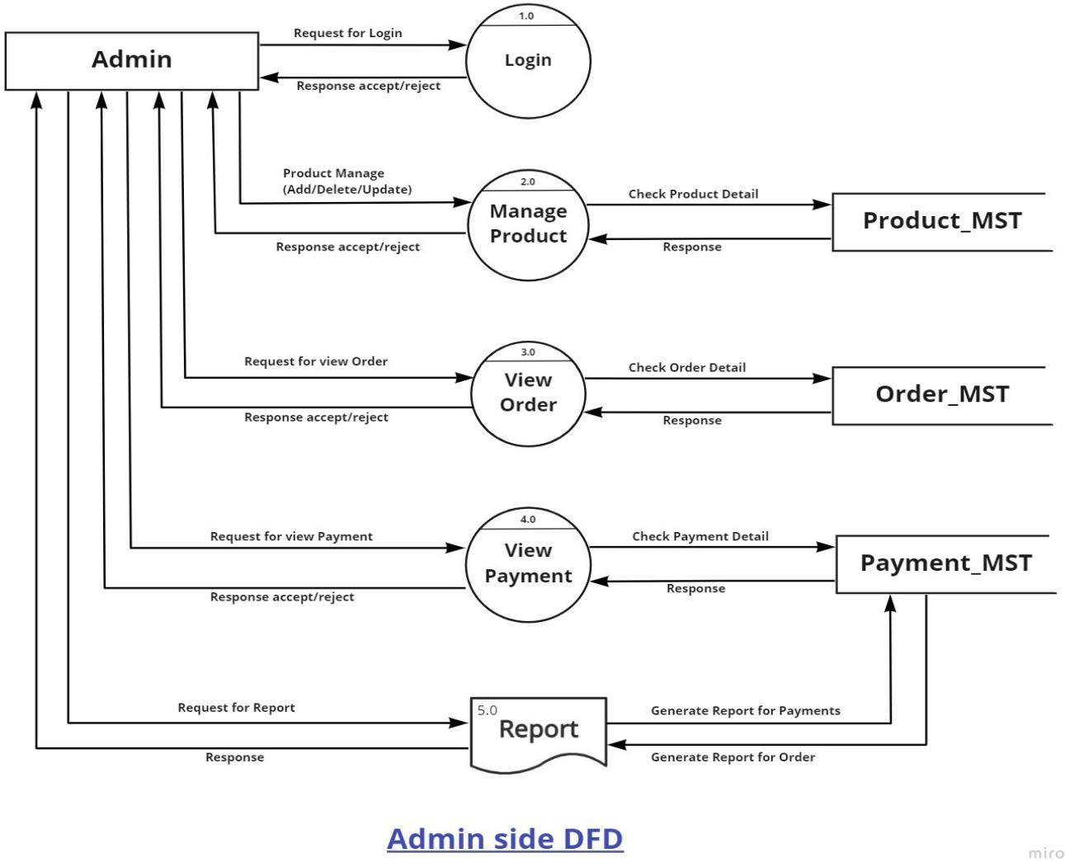

**7.4 SEQUENCE DIAGRAMS:**

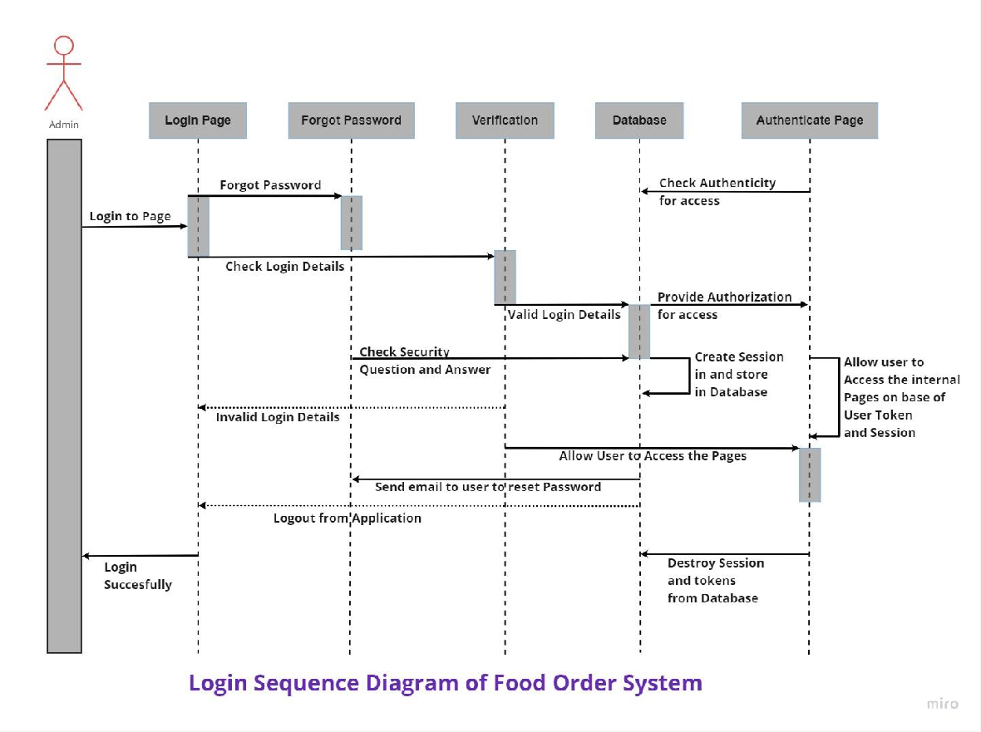Sequence diagrams for the e-Restaurant application depict the chronological order of interactions between system components and actors, illustrating message exchanges during processes like reservation making, order placement, and payment processing, facilitating a detailed understanding of system behavior.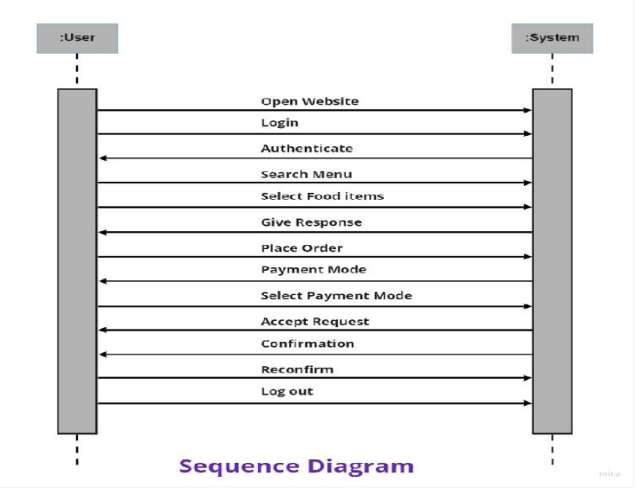

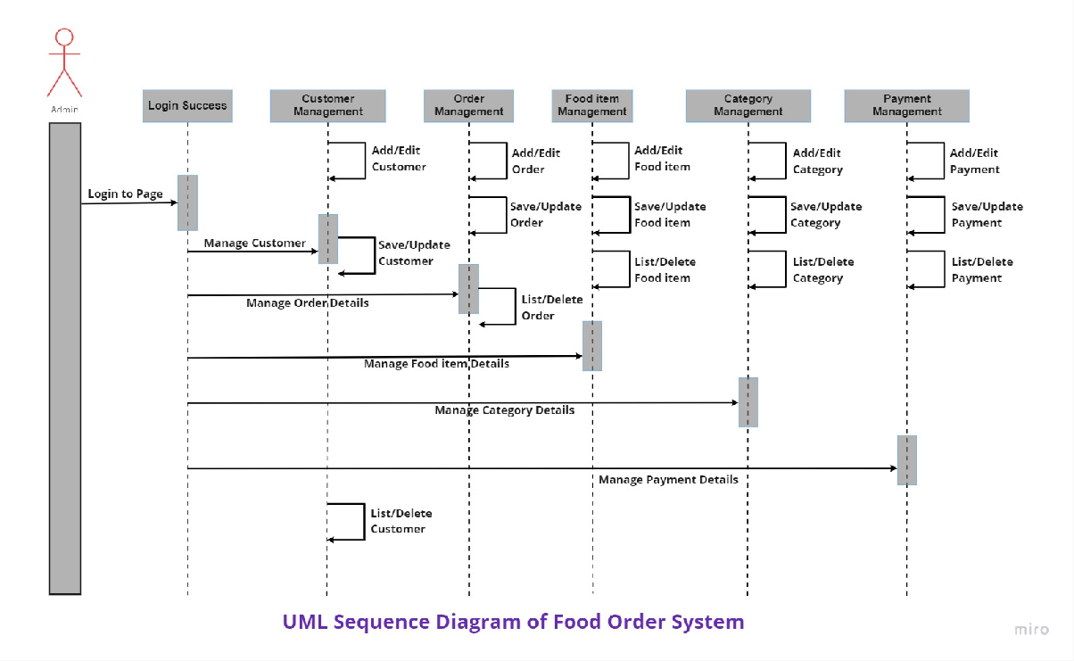

**Fig5.4:Sequence Diagram**

**7.5 ACTIVITY DIAGRAM**

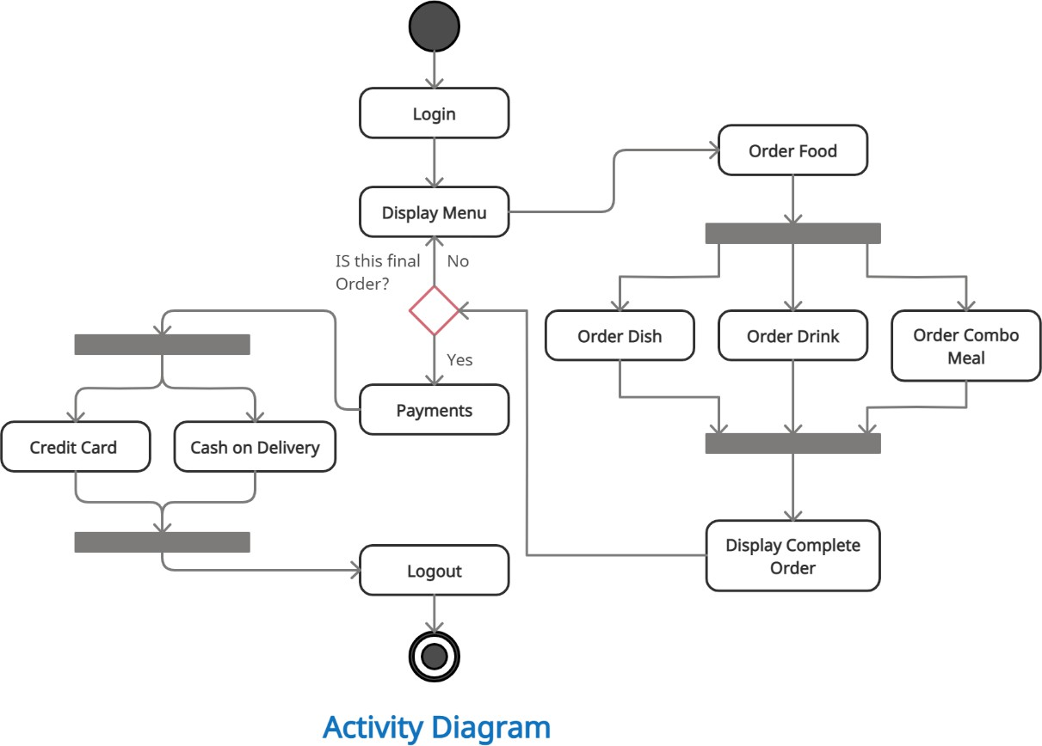Activity diagrams for the e-Restaurant application depict the flow of activities within specific processes, such as making a reservation or processing an order. They illustrate the sequence of actions, decisions, and interactions between users and the system, showing parallel and conditional activities. These diagrams provide a visual representation of process workflows, helping to identify potential bottlenecks, optimize processes, and ensure efficient system operation.

**Fig5.5: Activity Diagram**

**CHEPTER 7**

**FORM DESIGN**

**7.1 WELCOME PAGE OF FOOD MANIA**

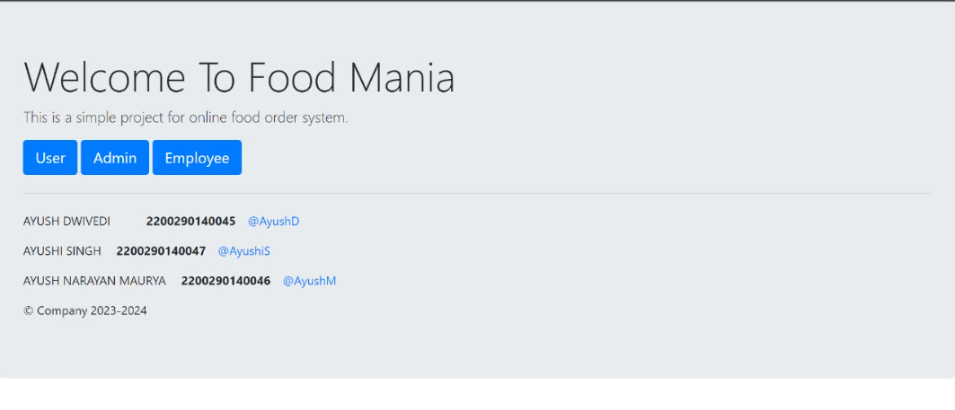

**Fig 7.1 Welcome Page of Food Mania**

The Welcome Page of Food Mania introduces users to the e-Restaurant application with a visually appealing design featuring the restaurant’s branding. It provides easy navigation to key features such as menu browsing, reservations, and user login or registration, ensuring a welcoming and user-friendly first impression.

**7.2 ADMIN HOME PAGE**

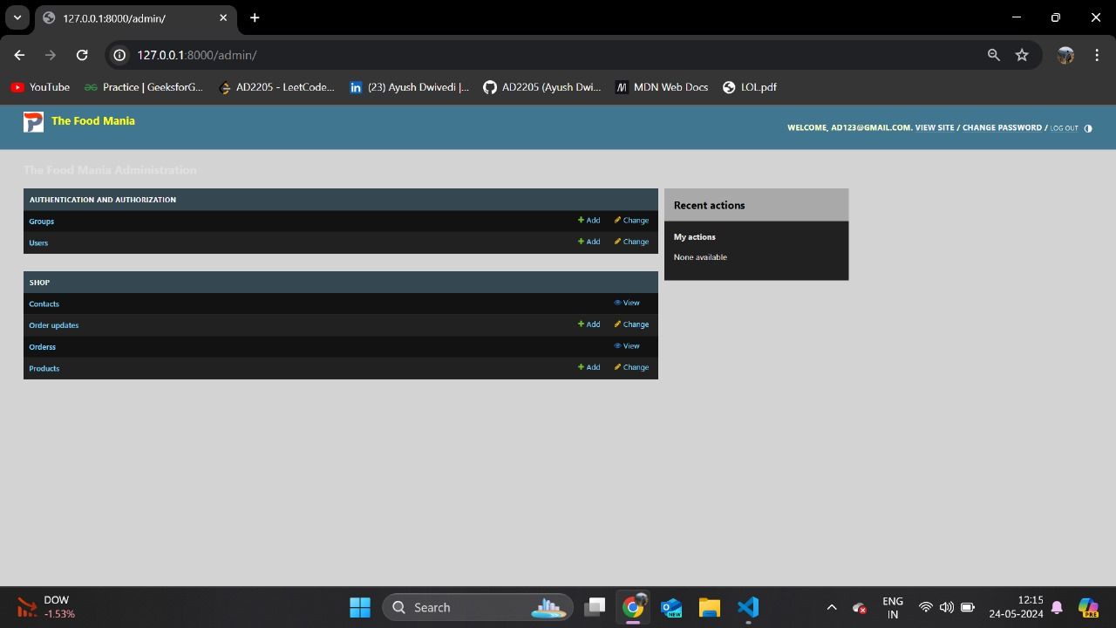

**Fig 7.2 Admin Home Page**

The Admin Page of Food Mania is a comprehensive control panel that enables administrators to manage the restaurant’s operations efficiently. It features functionalities such as user management, menu updates, reservation monitoring, and order tracking. Admins can generate reports, oversee inventory levels, and manage staff schedules. The intuitive interface ensures that administrators can perform tasks seamlessly, ensuring smooth operation and optimal performance of the e-Restaurant application.

**7.3 CONTRACT PAGE**

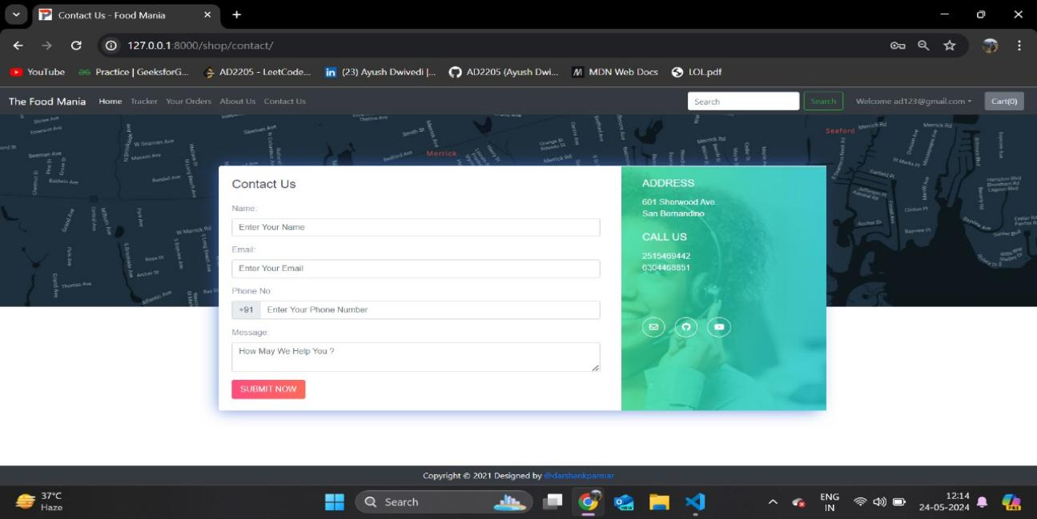 **Fig 7.3 Contract Page**

The Contract Page of Food Mania outlines the terms and conditions governing the use of the e-Restaurant application. It includes details on user responsibilities, privacy policies, payment terms, and dispute resolution procedures. This page ensures transparency and legal clarity, providing users with essential information about their rights and obligations.

**7.4 HOME PAGE**

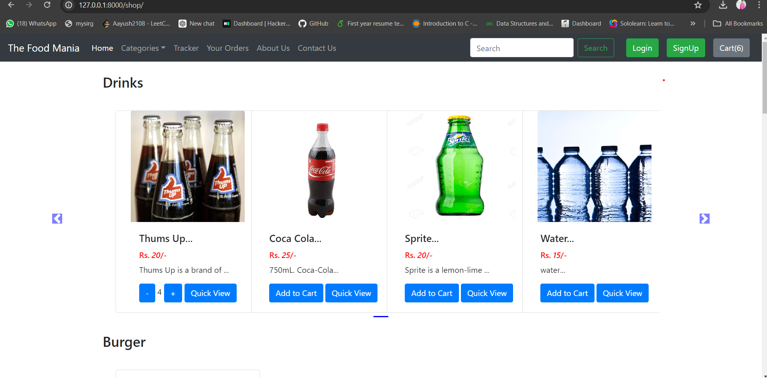

**Fig 7.4 Home Page**

The Home Page of Food Mania showcases a curated selection of restaurant-related products available for purchase. Items may include branded merchandise, gift cards, cooking ingredients, and meal kits. Each product is displayed with detailed descriptions, images, prices, and customer reviews. Users can add items to their cart, proceed to checkout, and make secure payments. The Home Page provides a convenient shopping experience, enhancing customer engagement and offering additional revenue streams for the restaurant.

Customers can easily browse through categories, add desired items to their shopping cart, and proceed to a secure checkout process that supports various payment methods. The page also highlights special deals, discounts, and seasonal promotions, encouraging customers to take advantage of limited-time offers. Additionally, gift cards are available for purchase, providing a perfect gift option for friends and family.**7.5 PRODUCT NAME**

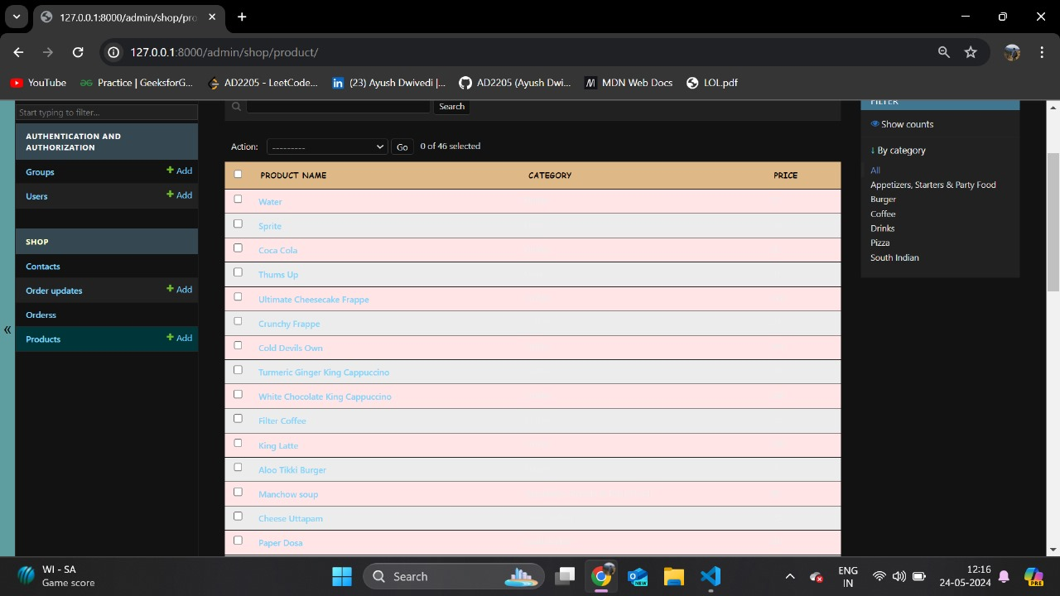

**Fig 7.5 Product Name**

The Product Name page in the e-Restaurant application provides detailed information about individual items available for purchase. This page features high-resolution images, comprehensive descriptions, pricing details, and user reviews for each product. It aims to give customers a clear understanding of the product's features and benefits, facilitating informed purchasing decisions.

**7.6 ORDER VIEW**

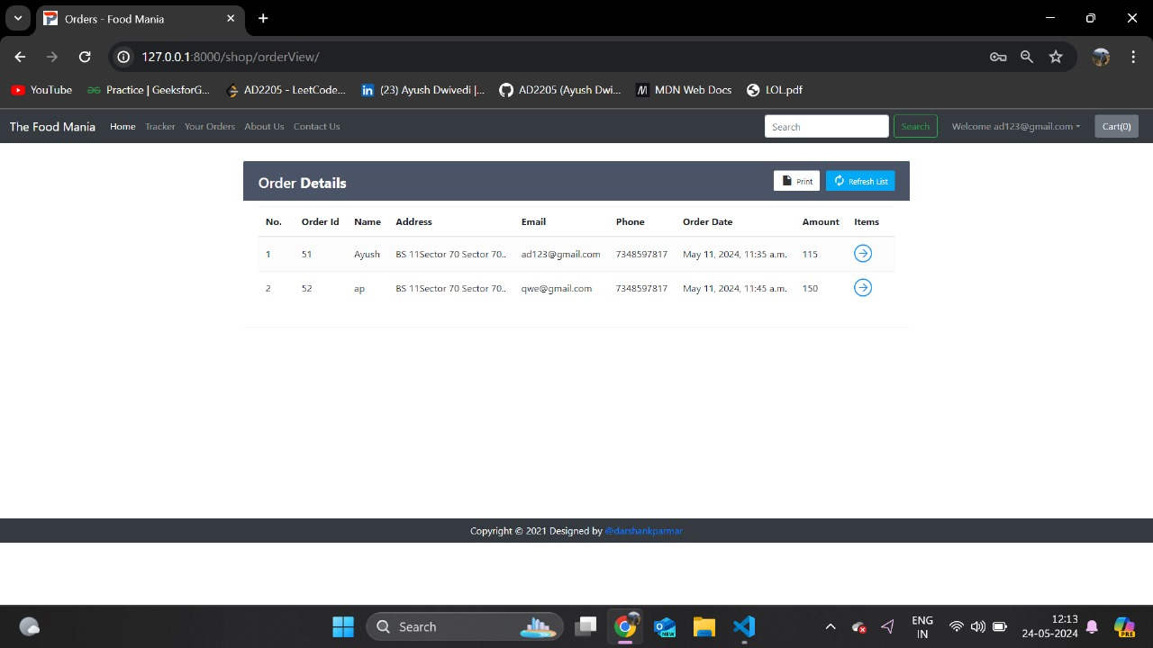

**Fig 7.6 Order View**

The Order View page in the e-Restaurant application displays detailed information about customer orders. It includes order status, itemized lists of ordered items, quantities, prices, and delivery or pickup details. This page enables staff to track and manage orders efficiently, ensuring timely preparation and delivery to customers.

**7.7 TRACKER VIEW**

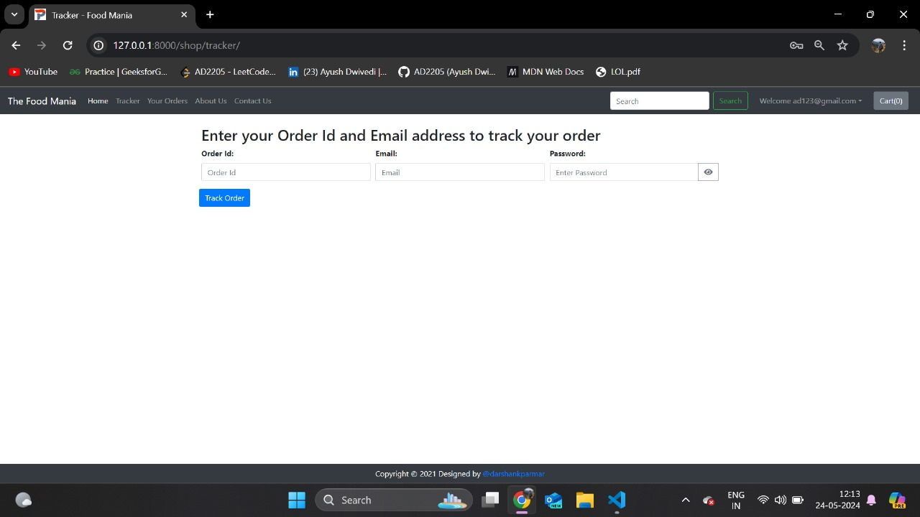

**Fig:7.7 Tracker View**

The Tracker View page in the e-Restaurant application allows users to track the status of their orders in real-time. It displays updates on order processing, preparation, and delivery, providing transparency and convenience for customers. This feature enhances user experience by keeping them informed and engaged throughout the order fulfillment process.

**7.8 CHECKOUT PAGE**

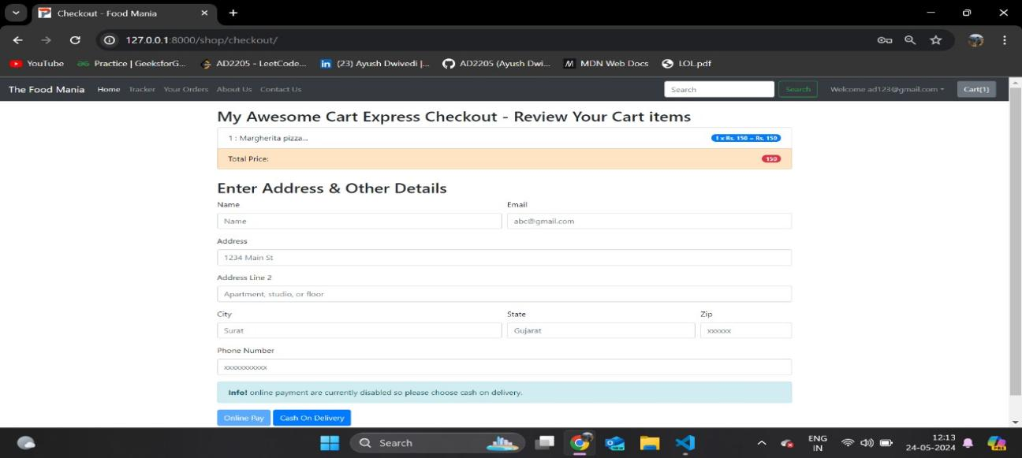

**Fig 7.8 Checkout Page**

The Checkout Page in the e-Restaurant application is where users finalize their orders and proceed to payment. It displays a summary of selected items, allows users to review and edit their order details, and provides options for payment and delivery preferences. This page ensures a smooth and secure transaction process, enhancing user satisfaction and completing the ordering experience.

**7.9 ORDER UPDATE**

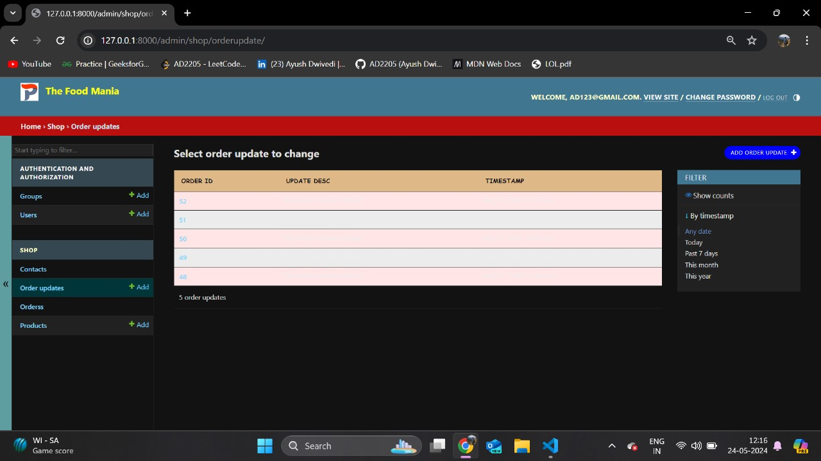

**Fig 7.9 Order Update**

The Order Update feature in the e-Restaurant application enables staff to modify and manage the status of customer orders. It allows for updates such as order confirmation, preparation, and delivery tracking. This feature ensures efficient order management and provides real-time updates to both staff and customers.

**7.10 CHANGE PRODUCT**

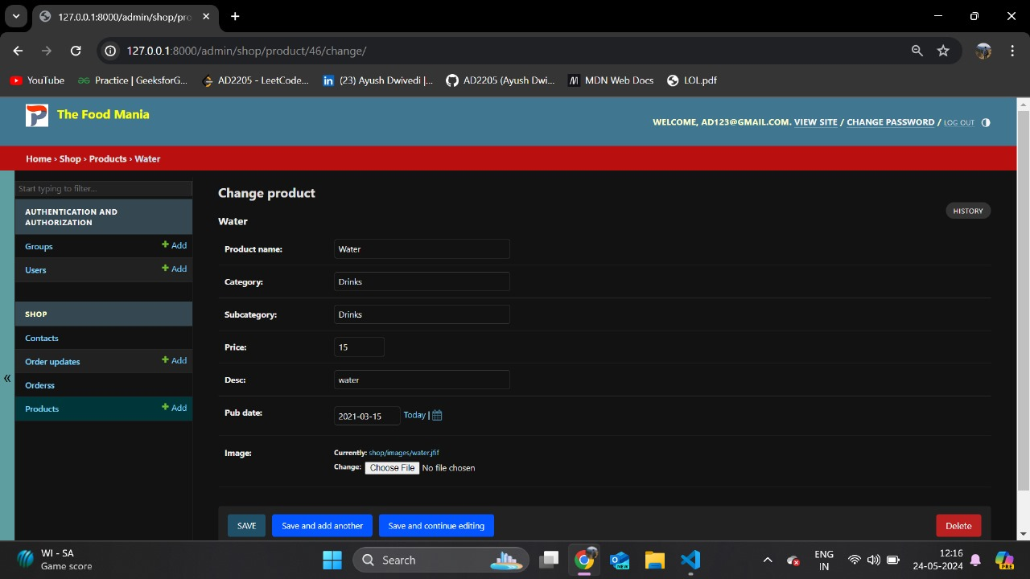

**Fig 7.10 Change Product**

The "Change Product" feature in the e-Restaurant application allows users to modify the items in their order before finalizing the purchase. Users can add new items, remove existing ones, or adjust quantities as needed. This feature provides flexibility and convenience, ensuring that users can customize their orders according to their preferences.

**7.10 ABOUT US**

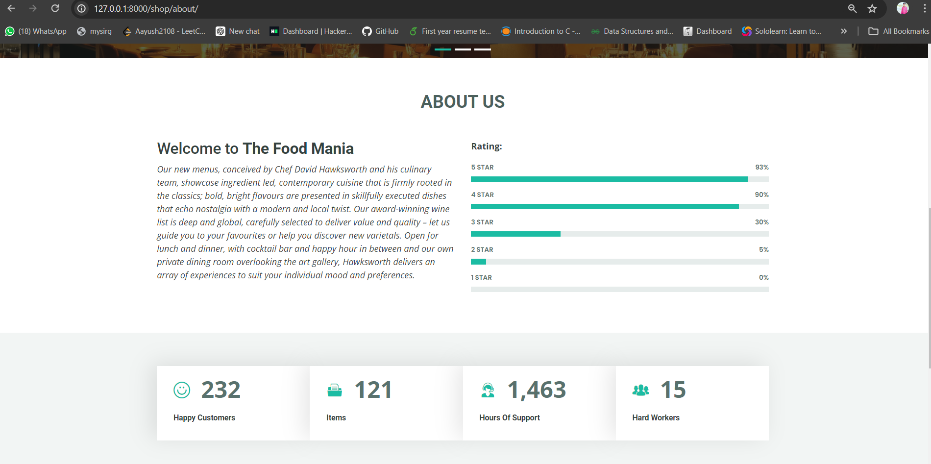

**Fig 7.11 About Us**

The "About Us" section of the e-Restaurant application provides users with insights into the restaurant's history, values, and mission. It showcases the restaurant's commitment to quality, sustainability, and customer satisfaction. Additionally, this section may highlight key team members, culinary expertise, and community involvement initiatives. By offering a glimpse into the restaurant's story and ethos, the "About Us" page aims to foster trust, connection, and loyalty among customers, enhancing their overall dining experience and relationship with the brand.

Our new menus, conceived by Chef David Hawksworth and his culinary team, showcase ingredient led, contemporary cuisine that is firmly rooted in the classics; bold, bright flavours are presented in skillfully executed dishes that echo nostalgia with a modern and local twist. Our award-winning wine list is deep and global, carefully selected to deliver value and quality – let us guide you to your favourites or help you discover new varietals. Open for lunch and dinner, with cocktail bar and happy hour in between and our own private dining room overlooking the art gallery, Hawksworth delivers an array of experiences to suit your individual mood and preferences.

**CHEPTER 8**

**TESTING**

**8.1 TESTING CASE 1 (Login)**

**8.1.1 Functional Test Cases-**

* Verify if a user will be able to login with a valid username and valid password.
* Verify if a user cannot login with a valid username and an invalid password.
* Verify the login page for both, when the field is blank and Submit button is clicked.
* Verify the messages for invalid login.

**8.1.2 Non-Functional Security Test Cases-**

* Verify the time out functionality of the login session.
* Verify the login page by pressing ‘Back button’ of the browser. It should not allow you to enter the system once you log out.
* Verify if a user should not be allowed to log in with different credentials from the same browser at the same time.

**8.2 TESTING CASE 2 (Adding Recipes)**

**8.2.1 Functional Test Cases-**

* Verify that the all required fields are filled.
* Verify that the ingredients are properly field with commas.
* Verify that the adding recipe will update to the list.
* Verify that the adding recipe will be available for the only registered user or not.
* Verify that the only registered user can edit or delete the save recipe.

**8.2.2 Non-Functional Security Test Cases-**

* Verify that the all fields are visible to the user.
* Verify that the “nav bar” should be visible for direct reach to the “All recipes” tab for show updated recipe.

**8.3 TESTING CASE 3 (Logout)**

**8.3.1 Functional Test Cases-**

* Verify After successful login in Pantry2Plate, click on the profile icon to check logout button is visible or not.
* Verify by Clicking on the sign-out button without an internet connection and reconnecting to the internet to check if it’s properly logout or not.
* Verify by clicking on the logout button, after successful logout on the login screen press the back button.
* Verify, login into more than two browser or mobiles and log out from anyone them and check all other account is properly working or all get logout.
* Verify after logout tries to re-login with the same or different account it’s allowing or not.

**8.3.2 Non-Functional Security Test Cases-**

* Verify the logs for the login and logout sessions.
* Verify if the logs contain multiple IPs for a single ID at the same time.
* Verify if the logs contain a denial-of-service attack for the login or logout.
* Verify if the log has suspicious activity.

**CHEPTER 9**

**BIBLIOGRAPHY**

* Node.js v20.9.0 and express 4.18.2 – Modern Cross-Platform Development: Build applications with express JS, node JS web development framework, MongoDB 7.0.2 and using VS Code 1.85.1.
* C. J. Date, A. Kannan, and S. Swaminathan, An Introduction to Database Systems, Pearson Education, Eighth Edition, 2009.
* Abraham Silber Schatz, Henry F. Korte and S. Sudarshan, Database System Concepts, McGraw-Hill Education (Asia), Fifth Edition, 2006.
* Pressmen, Somerville, Software Engineering: Design, Implementation, and Management.

**APPLICATIONS**

* [www.google.com](http://www.google.com/)
* [www.stackoverflow.com](http://www.stackoverflow.com/)
* [www.w3school.com](http://www.w3school.com/)
* [www.udemy.com](http://www.coderoject.com/)
* [www.gitHub.com](http://www.gitHub.com)
* [www.youtube.com](http://www.youtube.com)
* <https://unsplash.com/>
* <https://hoppscotch.io/>